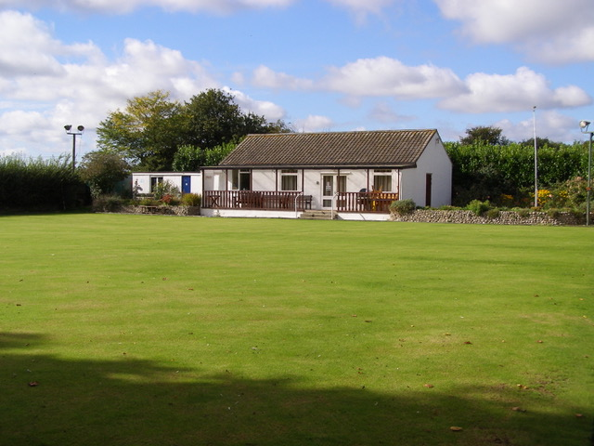  SOuthrepps LAWN  BOWLS ClUB  How can you get involved?  We are holding open days to invite individuals or groups to come along and try lawn bowls. Our members will be there to help and guide you.  If you want to come along as an individual, I can arrange to show you round prior to a bowl and to organize a suitable date for you.  If you want to come along as a group, we suggest groups of up to 9 people and we can designate a date specifically for your group. We are initially proposing Saturdays starting 11th of April and will continue whilst we have interest.  Dates and times are reasonably flexible so contact me so we can arrange a date to suit all.  Bowls will be provided, please wear flat soled shoes. | AN INVITATION TO HAVE A GO!  WE ARE LOOKING FOR NEW MEMBERS TO JOIN OUR VILLAGE BOWLS CLUB.  ────  Our members come from Southrepps and surrounding areas.  ────  It’s a great way to keep fit and spend spring and summer afternoons. Suitable for all ages from 18 upwards.  Contact  David Gollop  07850 463387  djg3mail@gmail.com

